Sir Hans Sloane MD:
the Irishman who collected the World
Dr Robert G W Anderson,
President of the Science History Institute, Philadelphia
Wednesday 14th March 2018 at 6.15pm
Royal College of Physicians of Ireland,
Winter Hall, RCPI, 6, Kildare Street, Dublin 2
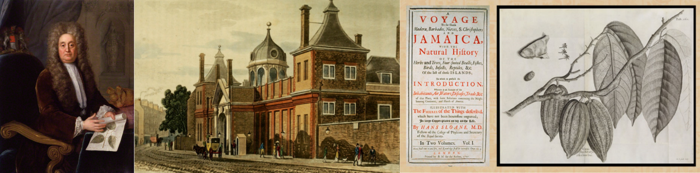

Sir Hans Sloane (1660-1753) created one of the most remarkable collections ever made by a private individual. Born in Killyleagh in County Down, he developed an early interest in natural history. As a young man, he studied medicine in London and Paris, and spent a year in Jamaica. Back in London he became a fashionable and wealthy physician, succeeding Sir Isaac Newton as President of the Royal Society. As a collector, his activities seemingly had no disciplinary boundaries. He bequeathed his collection to an unenthusiastic government and it had to be by means of a lottery that the British Museum was founded.

Admission is free but please register at https://www.rami.ie/event-registration/history-medicine-section-wednesday-14th-march-2018/5468

